**P615/1/2 & 3 Inst. Sch.**

**INSTRUCTIONS**

**FOR ART**

**Paper 1, 2, & 3**

**Jul/Aug 2019**

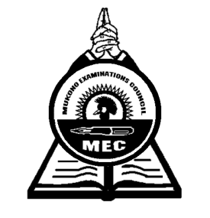

**MUKONO EXAMINATION COUNCIL**

**Uganda Advanced Certificate of Education**

**ART CONFIDENTIALS**

Papers 1, 2 & 3

**Note:**

*Great care should be taken that the information given below does not reach the candidates either directly or indirectly.*

**INSTRUCTIONS FOR PREPARING THE ITEMS**

*This information is given only to facilitate the preparation of the examination.*

*The head teacher should make sure that the teacher responsible for preparing items gets all items before the examination.*

**LIST OF ITEMS**

The following items should be made available for setting not more than two hours to the sitting of the paper on the day of the examinations

**Paper 1 (P615/1)**

* White Art papers (Standard size)
* A round rolling board
* A kilo of fresh meat (chopped ribs)
* A 3 litre cooking oil jerry-can
* A new knife
* Fruits (large tomatoes, onions and large egg plants (Biringanya)
* A building
* Trees
* Large- leaf creeping plant (approx. 60cm long)
* A dry branch
* **Paper 2 (P615/2)**
* 2 models
* Pair of shorts
* A T-shirt
* A stool or any craft seat of (about 30cm high)
* A basin (approx. 44cm diameter and 15 cm high).
* A vest
* An office chair
* A table
* Shallow plate
* **Paper 3 (P615/3)**
* White Art Paper (standard size)
* Letrasets
* Rulers
* Coloured inks, pens, pencils, Rubbers, strings, junk wire, Paints, Markers e.tc
* Lino Blocks,
* Sponge
* Markers
* A Pair of compass etc

**END**